**E-ASSESSMENT USING IMAGE PROCESSING IN ∞EXAMS**

.

Here i design two modules

Faculty Module: Faculty will login to application using username and password as ‘faculty’ and ‘faculty’. After login faculty will upload scan question paper images to application and then application will process uploaded images using OPENCV library to detect shadow circles as answer of the question. In this library application will accept image which has five questions. Based on verification of image result will be display.

Student module: Application will ask student to enter his name and based on name his marks will be fetched and display to the student.

Graph module: In this module pie chart will be generated using all students’ marks.

Screen shots

Double click on run.bat file to get below screen

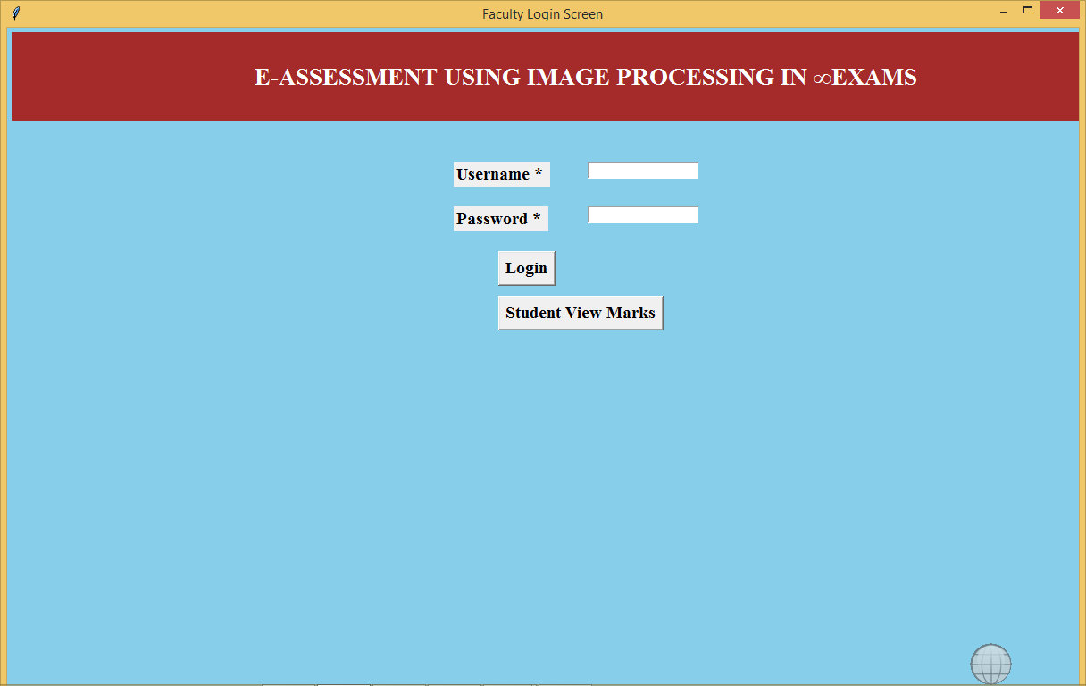

In above screen enter username as ‘faculty’ and password as ‘faculty’ to login and after login will get below screen

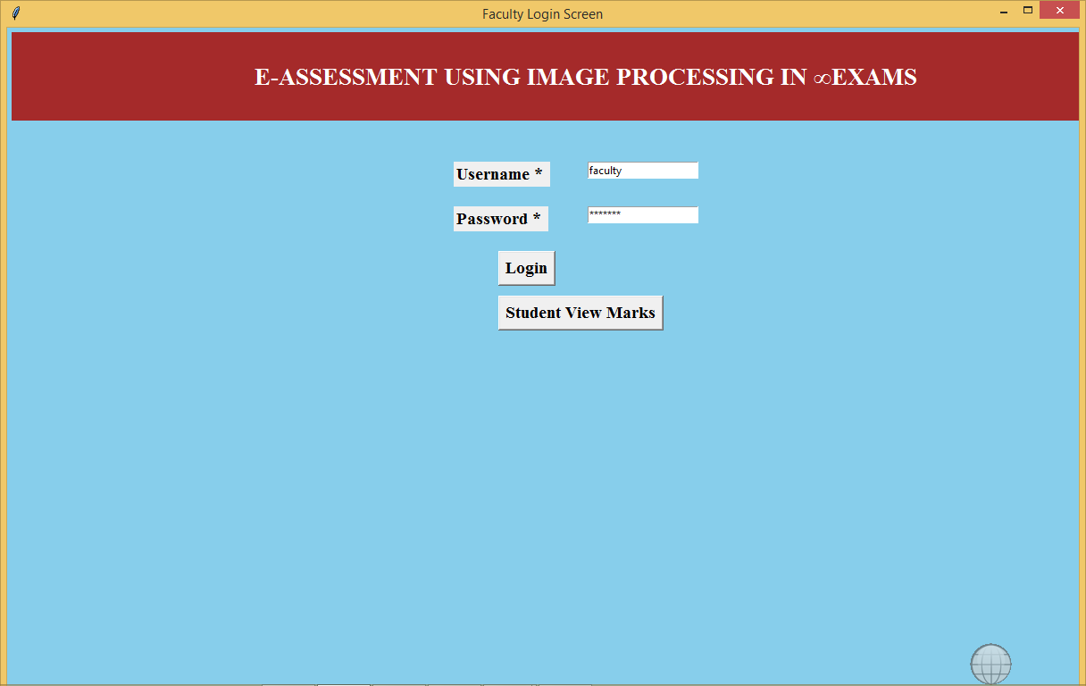

After login will get below screen

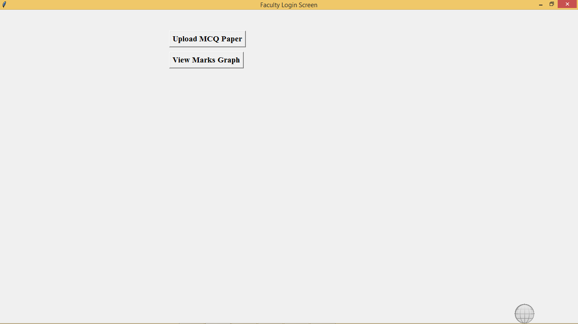

In above screen click on ‘Upload MCQ Paper’ and enter student name and upload question images

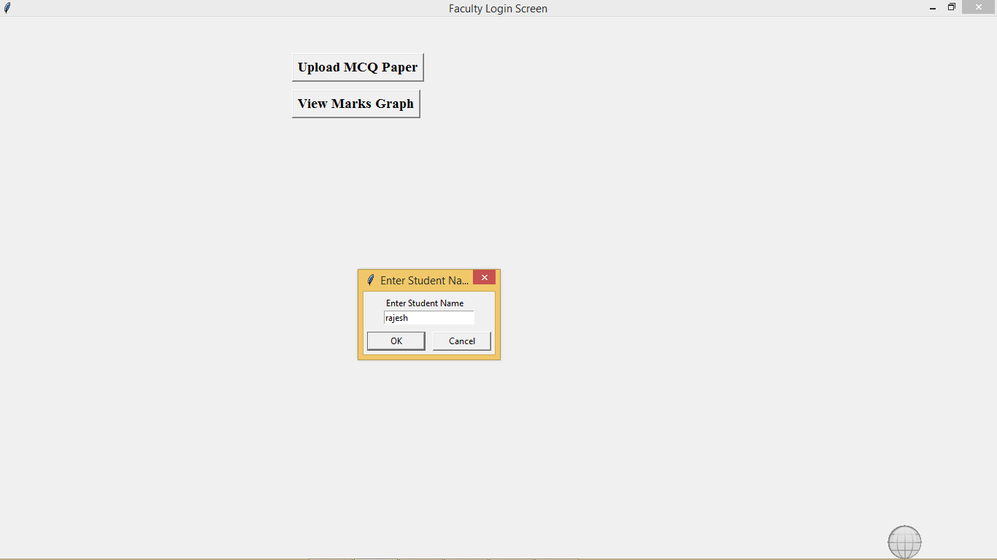

In above screen click ‘ok’ button to upload image

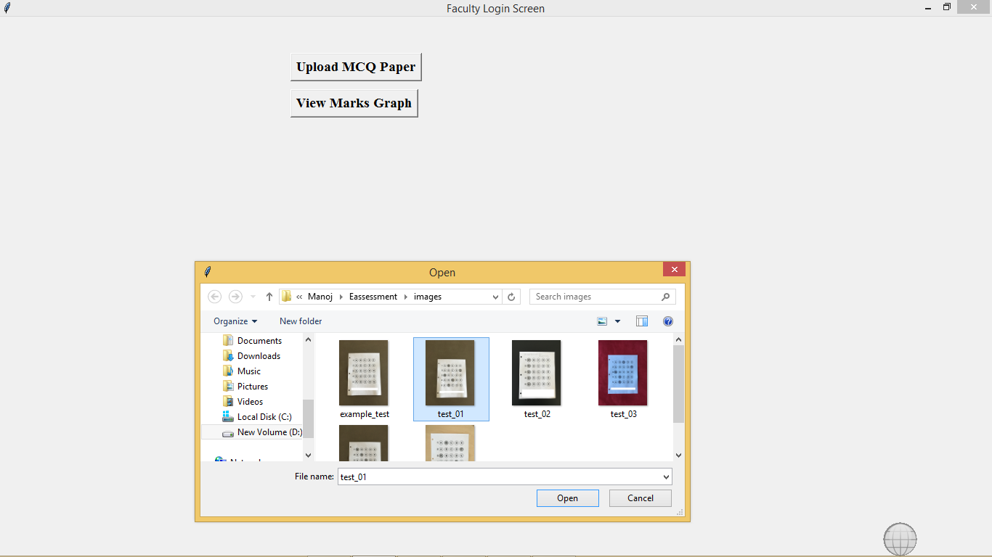

In above screen selected one image now click open to process that image

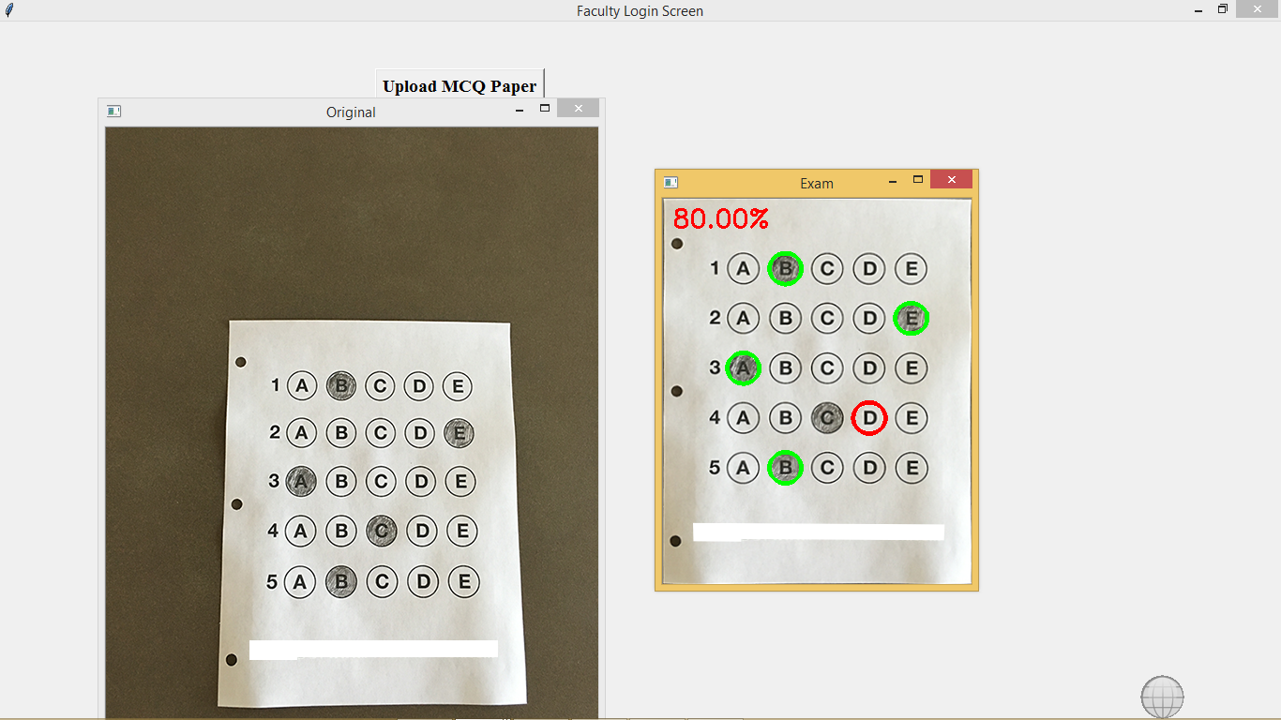

In above screen we can see student answers at left side image and corrected image at right side where wrong answer mark with red colour. Similarly we can upload any number of images. Each image must have five questions and left side paper must have three dot symbols.

Now click on ‘View Marks Graph’ to get below chart

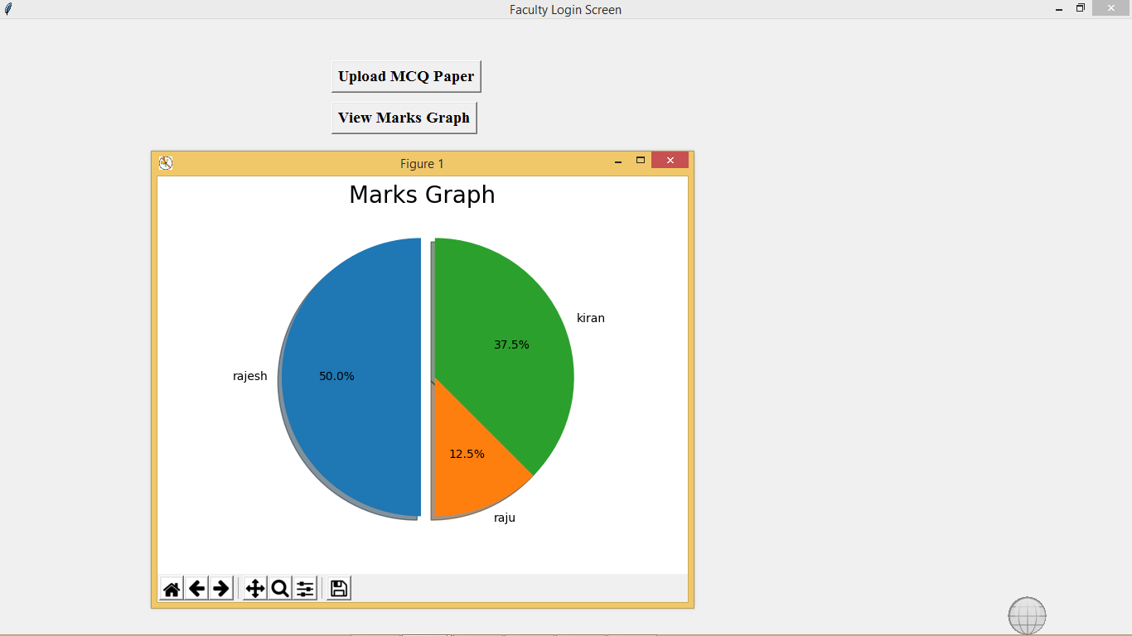

In above graph we can see marks obtained by each student. Similarly student can see their marks by entering their name. See below screen

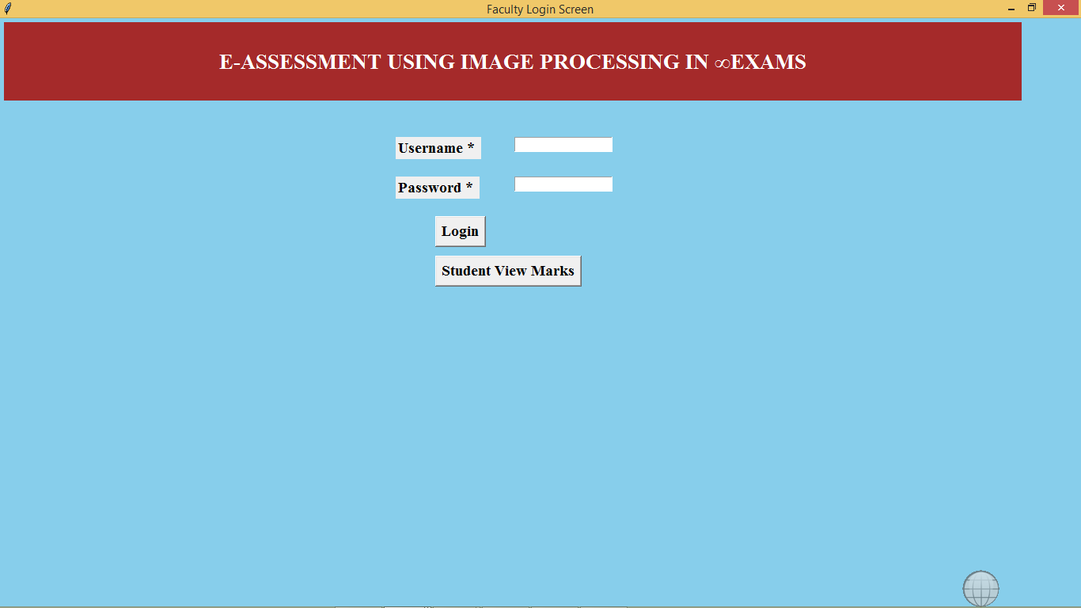

In above screen click on ‘Student View Marks’ button to get below dialog box

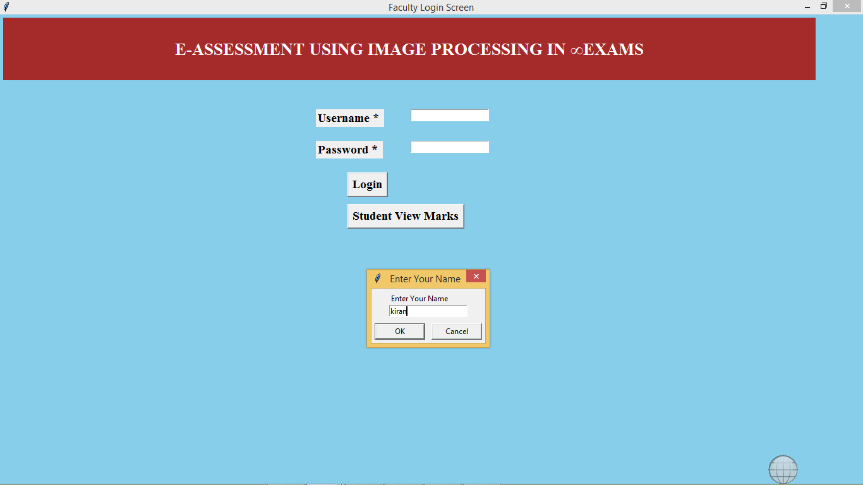

In dialog box enter student name to get his marks

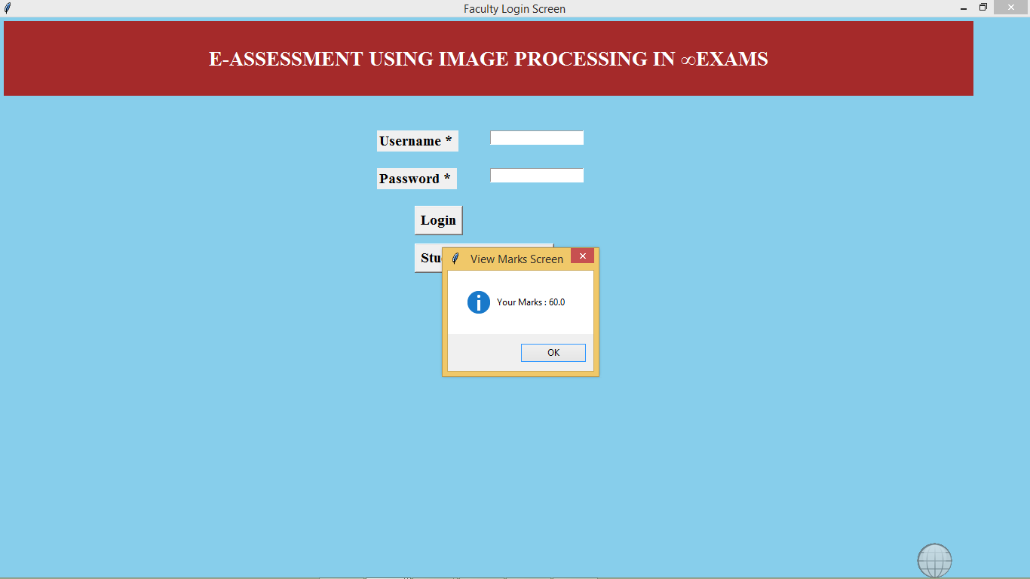

In above screen we can see student got 60% marks